Transmittal of augmentation scenario model data files and results

Sam Perkins and Ginger Pugh

Kansas Department of Agriculture-Division of Water Resources

January 16, 2015

Two augmentation scenarios were developed at KDA-DWR, both with the original multilayer GMD5 model and with the single-layer version produced by Steve Larson, S.S. Papadopulos and Associates, model reviewer for DWR. Model backup files are posted that can be used to run the scenarios (file augmentation_scenarios.zip).

Model results consist of text output files containing streamflow and computed head hydrographs that are produced by running the scenarios, and which were used to construct the graphs of results presented below. The hydrograph text files are packaged separately as file augmentation_output_hydrographs.zip.

**Transmittal document contents**

               Posted model backup

               Description of augmentation scenarios

               Organization of model backup files

               Pre- and postprocessors

Augmentation scenario results

**Posted model backup**

Posted files are at <http://dwr.kda.ks.gov/20150115_GMD5_augmentation_model_runs/> and include:

augmentation_model_run_transmittal_2015_0116.docx (this file)

augmentation_scenarios.zip (3 MB): incremental backup file;

augmentation_output_hydrographs.zip (1 MB): text files with results used to calculate impacts;

GMD5_Aug_Cells.pdf: reference map.

Augmentation scenario files are packaged as an incremental backup whose contents can be added to the previous backup of model scenarios, posted November 5, 2014.

Let us know if you have any questions or encounter any problems retrieving or using these files.

**Organization of model backup files**

The files in the incremental backup are organized according to the following main folders:

                Aug_scenarios

                                Src                                                          source files for pre- and postprocessing programs

                                1L                                                            1-layer model versions

                                                Bin executables for 1-layer model version

                                                Scenarios

                                                                Bat                         batch files for running scenarios

                                                                In                            location where input files for Modflow are written

                                                                Mkstr                    SFR preprocessor input

                                                                Nam                      MODFLOW name files

                                                                Out model and postprocessor output

                                                                Post

                                                                Posthyd               postprocessor input files

                                                                Pre                         WEL preprocessor input files

                                ML                                                          multilayer model versions [same structure as 1L]

In order to run the augmentation scenarios, the posted files should be copied to corresponding folders of previously provided model runs. Text versions of batch files are provided that can be used to run the two scenarios in scenarios\bat of the 1L and ML model versions.

**Description of augmentation scenarios**

The first scenario follows your suggestions; four wells were located 1-2 miles from Rattlesnake Creek to the northeast of St. John (see Fig. 1) that together pumped roughly 1200 acre-feet of water to Rattlesnake C into segment 1555 at a combined rate of 6.7 cfs for three months April-June for six years 1988-1993. The map in Fig. 1 identifies the locations of the augmentation pumping wells and the stream segment where augmentation flow is input.

The second scenario maintains the same location of the four augmentation wells and point of input to Rattlesnake C, but with the pumping schedule following recommendations of the 2006 Kansas Water Office report on augmentation, to provide 1460 ac-ft for two months August-September in years when average flow at Zenith in January is less than 25 cfs, except in years of severe drought as determined in July.

Placement of augmentation pumps and flow to Rattlesnake C in the model:

Augmentation well locations and share of pumping (specified by input to preprocessors OneLayerWell_scenariosAug and MultilayerWell_scenariosAug, described below):

1,87,247,0.25

1,87,248,0.25

1,88,247,0.25

1,88,248,0.25

Added augmentation input to stream segment 1955 (specified by input to preprocessor StreamScenariosAug):

1955,segaug

Map 1. Placement of augmentation pumps and corresponding stream segment.

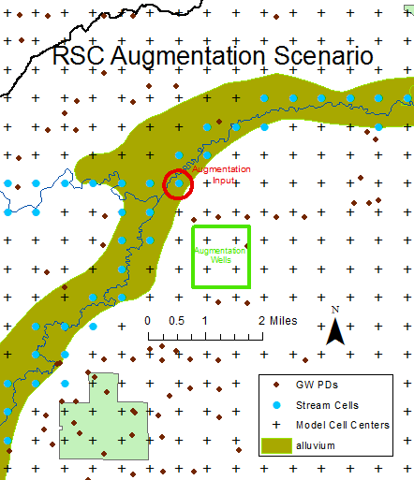

A second graph, posted on the ftp site as file GMD5_Aug_Cells.pdf, expands the map extent to show Rattlesnake C from St. John to the Quivira Wildlife Refuge.

**Pre- and postprocessors**

Four processors were developed as versions of previously provided processors:

OneLayerWell_scenariosAug: allows specifying a group of augmentation wells that share a specified augmentation flow rate, cfs (note sign: negative for extraction, positive for injection); months and years of augmentation are also specified. The augmentation wells are added as a revision of a specified WEL file.

MultiLayerWell_scenariosAug: nearly identical to OneLayerWell_scenariosAug; baseline wells pump from originally specified model layers.

StreamScenariosAug: Allows specifying a corresponding schedule of augmentation inflow to a stream segment. Specified augmentation flow is included by adding to runoff input to segment. The SFR package input file produced by this program is used for both single- and multilayer model versions. Note: the name files for the multilayer model versions refer to sfr files in the single-layer model folders.

cbcReaderHyd: Allows specifying hydrographs to be read from model output and written to a text file named [case name].hdo. Format of input to cbcReaderHyd is similar but not exactly the same as input to Hydmod. Nineteen hydrographs were specified: five of stream segment outflow (‘SO’) including Macksville and augmentation segment, Zenith; and fourteen of computed heads (‘HD’) mostly transverse to segments where ‘SO’ hydrographs are specified, including at an augmentation well and at the augmentation stream segment.

For the multilayer model, cbcReaderHyd operates exactly as for single-layer model, but is used only to extract streamflow (‘SO’) hydrographs, which cannot be specified by HYDMOD due to a segment-numbering restriction to three digits (1-999). The remaining fourteen hydrographs are produced by HYDMOD and written to a file named [case name].hgr as specified in the name file. cbcReaderHyd is not used for these because computed heads are not saved for every time step when the multilayer model runs; only ending heads (end of 2007) are saved. The Excel file build_hydmod_input_files.xlsx in ML\scenarios\posthyd was used to construct the HYDMOD input file for these.

**Augmentation scenario results**

A second map, on file GMD5_Aug_Cells.pdf and posted on the ftp site, shows Rattlesnake C. from St. John to Quivira Wildlife Refuge and identifies locations of stream segments where streamflow hydrographs are plotted in figures 1-6 below for the augmentation scenarios.

Model and postprocessor output used to calculate impacts shown in graphs are included with the model backup in the 1L\scenarios\out\ and ML\scenarios\out\ subfolders.

For the 1-layer model scenarios, graphs of augmentation impacts shown below are based on hydrographs read from model output files by program cbcReaderHyd and written to text files with extension **.hdo**. Input to cbcReaderHyd specifies five stream segment outflow hydrographs (identified by the code ‘SO’ and segment number in the graph legends) and fourteen computed head hydrographs (identified by the code ‘HD’ and location description in the graph legends)

Graphs of augmentation impacts are based on similar hydrograph output, except that only the stream outflow hydrographs are produced by cbcReaderHyd and written to text files with extension **.hdo**. The remaining fourteen computed head hydrographs are produced by hydmod during model execution and written to text files with extension **.hgr** as specified in the name files.

**Scenario 1. 6.7 cfs augmentation Apr-Jun in 1988-1993.**

Graphs of time series for 1988-2007 that are shown below as Figs. 1-3; both single- and multilayer model versions are shown for comparison (corresponding to Figs. 1S and 1M and so on). Legends indicate stream segment outflow hydrographs by ‘SO’ in all figures, and computed head hydrographs by ‘HD’ in Fig. 1 only.

Fig. 1 superimposes plots of streamflow response at the augmentation inflow segment 1955 and at Zenith (seg 1997) with drawdown at one of the augmentation wells and at segment 1955.

Fig. 2 superimposes the augmentation pumping and the streamflow response at inflow (seg 1955), sw corner of refuge region (seg 1983) and at the Zenith gage (seg 1997). The second map posted on the ftp site identifies where the refuge and Zenith gage segments are located.

Fig. 3 plots cumulative streamflow response as a fraction of augmentation pumping at three locations: outflow from the reach where the flow enters the stream (seg 1955) and downstream a little southwest of Quivira Wildlife Refuge (seg 1983) and near the Zenith gage (seg 1997). These curves represent the cumulative effect of not only the periodic increase in flow in Apr-Jun of 1988-1993 but also the stream depletion due to the pumping by the augmentation wells. Cumulative streamflow response as a fraction of augmentation pumping at the end of 2007 near the Zenith gage (segment 1997) is 0.397 for the single-layer version and 0.414 for the multi-layer version.

**Scenario 2. 12.1 cfs augmentation Aug-Sep in years with avg. January flow at Zenith below 25 cfs**

Fig. 4 superimposes plots of streamflow response at the inflow segment 1955 and at Zenith (seg 1997) with drawdown at one of the wells and at the inflow segment.

Fig. 5 superimposes the augmentation pumping and the streamflow response at inflow (seg 1955), sw corner of refuge region (seg 1983) and at the Zenith gage (seg 1997).

Fig. 6 plots cumulative streamflow response as a fraction of augmentation pumping for the stream segments at inflow (seg 1955), sw corner of refuge region (seg 1983) and at the Zenith gage (seg 1997). Cumulative streamflow response as a fraction of augmentation pumping at the end of 2007 near the Zenith gage (segment 1997) is 0.4717 for the single-layer model version and 0.4936 for the multilayer model version.

Figs. 1-3. [Scenario 1: 6.7 cfs augmentation Apr-Jun in 1988-1993]

Fig. 1S. single-layer model version.

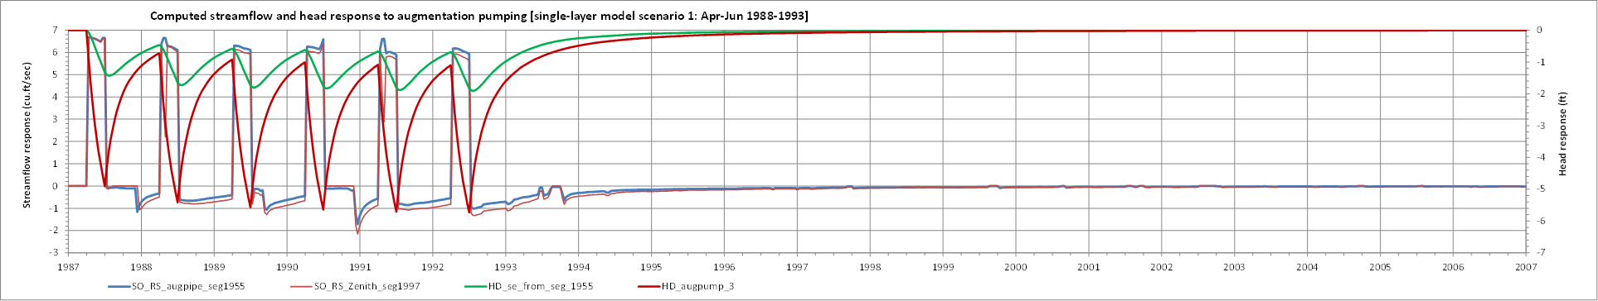

Fig. 1M. multilayer model version.

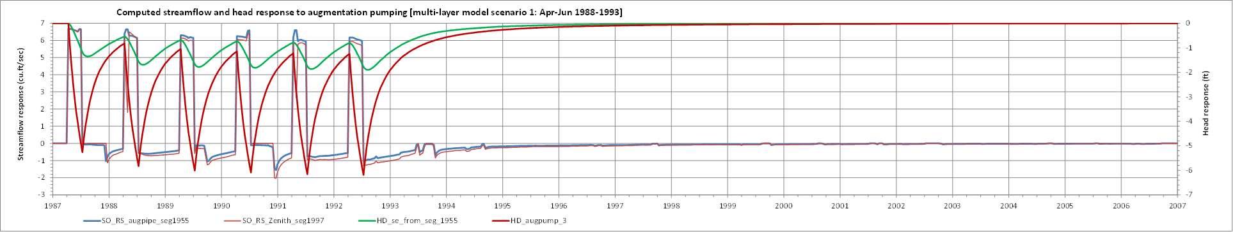

Fig. 2S. single-layer model version.

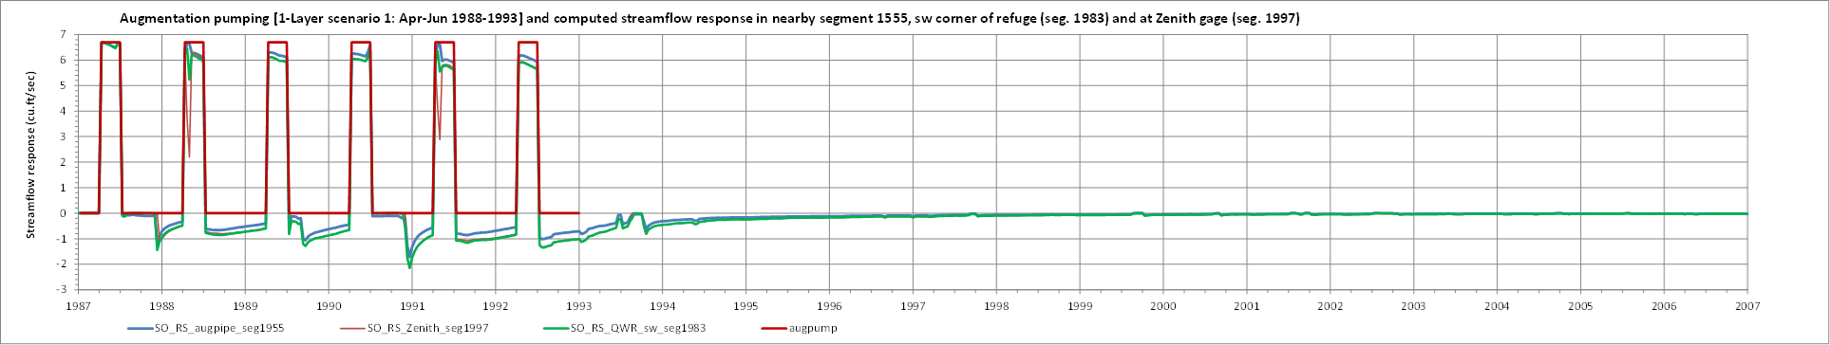

Fig. 2M. multilayer model version.

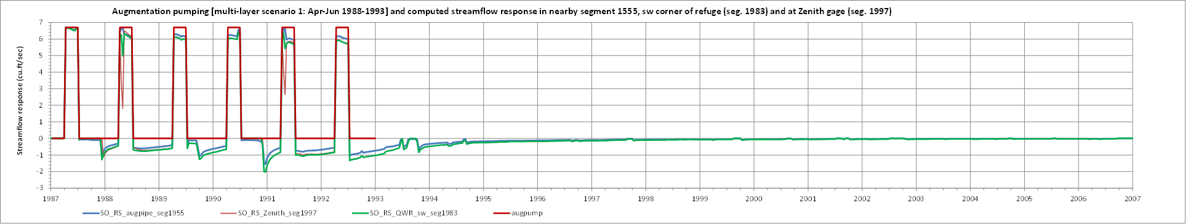

Fig. 3S. single-layer model version.

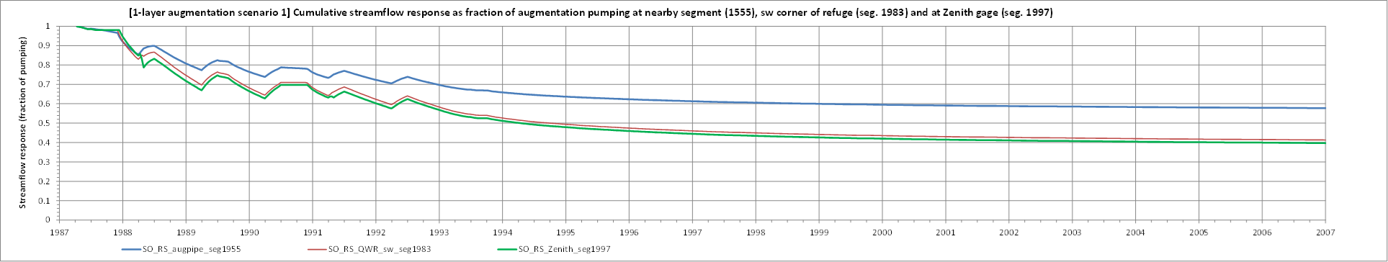

Fig. 3M. multilayer model version.

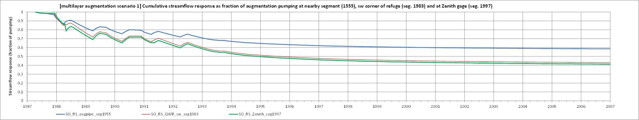

Figs. 4-6. [Scenario 2. 12.1 cfs augmentation Aug-Sep in years with avg. January flow at Zenith below 25 cfs]

Fig. 4S. single-layer model version.

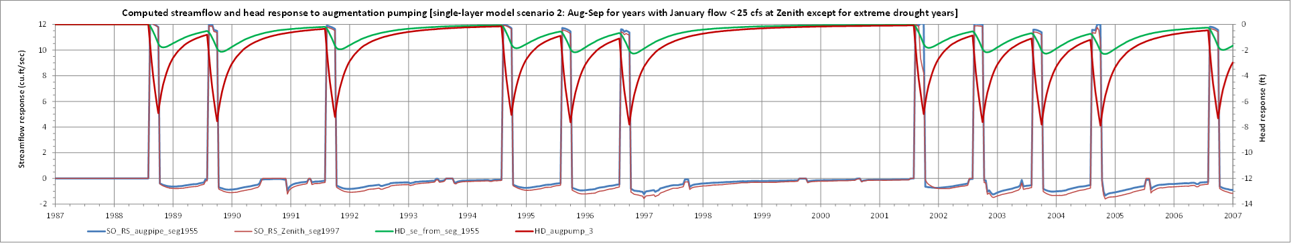

Fig. 4M. multilayer model version. 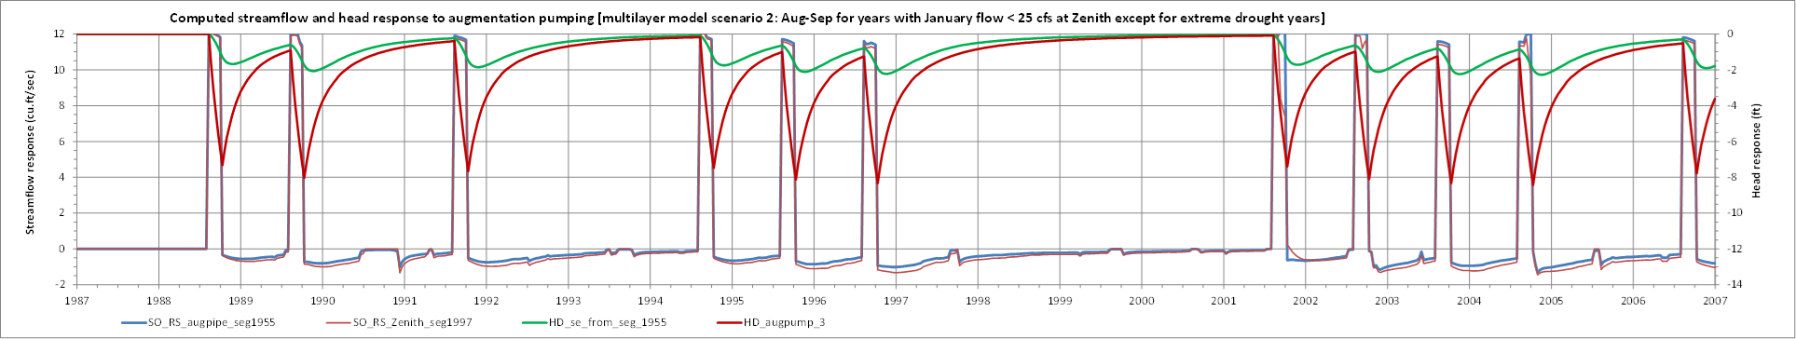

Fig. 5S. single-layer model version.

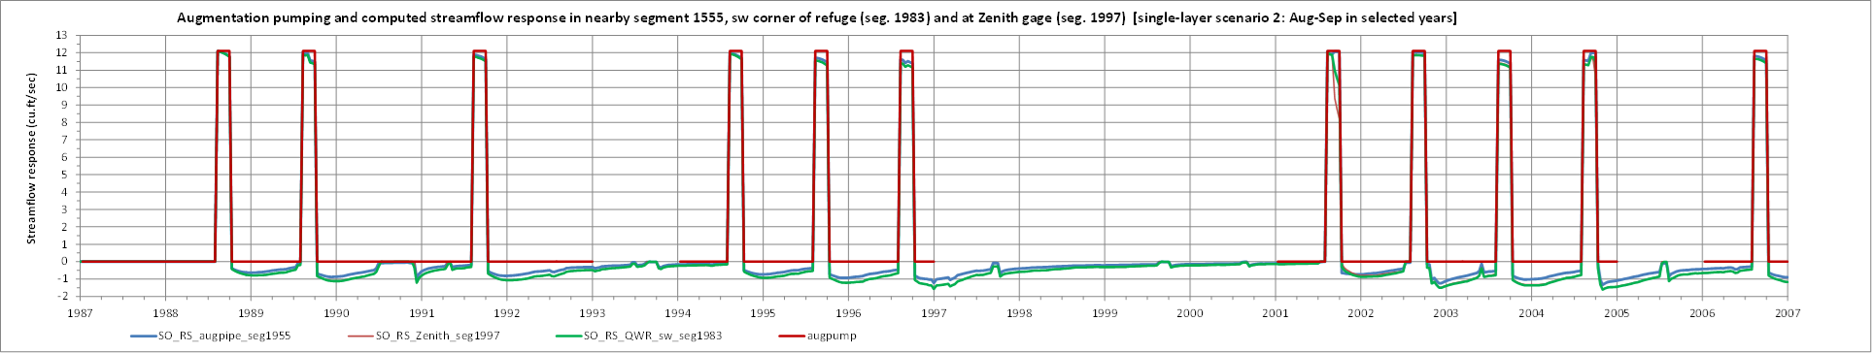

Fig. 5M. multilayer model version.

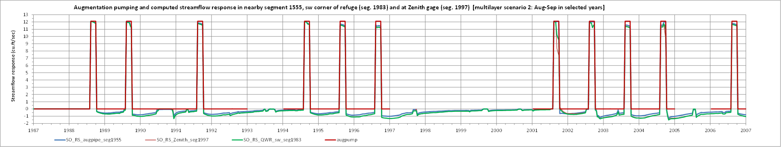

Fig. 6S. single-layer model version.

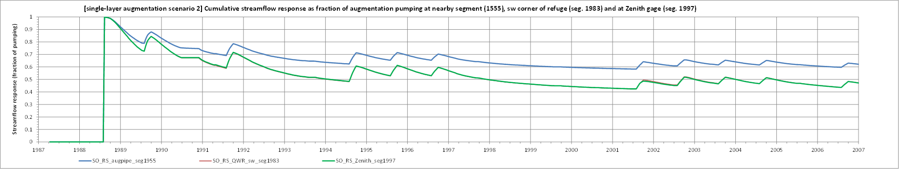

Fig. 6M. multilayer model version.

