Memo: Review of GMD5 groundwater model scenarios produced by KDA-DWR
Narrative for GMD5 model backup files in build_GMD5.zip
Sam Perkins
June 19, 2017

Model scenarios were developed in 2014 to help provide a basis for an impairment investigation for USF&W File 5751 by quantifying streamflow depletions by groundwater pumping in Rattlesnake Creek subbasin, especially depletions to Quivira Wildlife Refuge (QWR) inflow. Model scenarios were developed in 2015 for a preliminary assessment of augmentation impacts on both streamflow and groundwater. After completion of the investigation, which found that impairment had occurred, additional model scenarios were developed beginning in September 2016 to help determine the spatial extent and distribution of pumping impacts to Rattlesnake C (RSC) streamflow, primarily at the Zenith gage, which lies just above diversions to QWR.

Single-layer model scenarios 12 and 13 were developed in 2016 to investigate impacts of pumping outside the RSC basin on streamflow at Zenith. A multilayer version of scenario 13 in folder ML was run for comparison with the single-layer version. Scenario 16 was developed to be used in mapping the spatial distribution of depletion response to pumping in the RSC basin and in GMD5. The response map (Fig. 2) depicting Rattlesnake C depletion response at Zenith to pumping from a given location in GMD5 is also based on historical simulations with the one-layer model.

The most recent scenarios, developed in May 2017 have been prospective, i.e. variations on projected future conditions, to help assess the magnitude of future depletions and the projected impacts of pumping reductions. The May 2017 scenarios have been based on the multilayer model (folder ML) as variations on Balleau’s Baseline A (BL_A) future projection of years 2008-2075, which repeats the chronology of 1940-2007 historical conditions but with current irrigation development and post-1970’s precipitation recharge relationships.

Sheet ‘cases’ in accompanying Excel file GMD5_scenario_list.xlsx lists scenarios that can be run with the data in the backup file, the dates of their name files and brief descriptions. Model runs with associated preprocessors and postprocessors are documented by batch files that record how the computer programs were run, and are located in ‘bat’ subfolders within ‘simulation’ for retrospective model runs, and ‘BL_A’ folders for prospective model runs.

2014 scenarios: investigate impacts of pumping within Rattlesnake C Basin (previously provided)

These scenarios are numbered 1-11 and are all based on the single-layer model version, but with a multilayer version of scenario 11 identified as 11ML for comparison. Selected descriptions:
Scenario 1: Shut off all groundwater irrigation pumping within RSC subbasin that are upstream and junior to File 5751 beginning in 1958, the first calendar year after the File date in August, 1957.
Scenarios 2: Variation on Scenario 1 with basin-wide pumping shutdown beginning in 1990.
Scenarios 3-11: Variations on Scenario 2 with subsets of pumping selected for shutdown beginning in 1990.

2015 scenarios (augmentation): both single- and multilayer model versions (previously provided)

2016 scenarios: impacts of pumping outside RSC; spatial distribution of impacts (response map)
The 2016 scenarios were developed to run with the 1-layer version of the GMD5 groundwater model. Scenarios 12 and 13 are variations on scenario 1 that were developed to investigate RSC streamflow depletion by pumping outside the RSC basin. Under Scenario 1, all pumping in RSC basin junior to File 5751 was shut down beginning in 1958. Scenario 16, described below, was used to develop a map of RSC-Zenith depletion response to pumping across the RSC basin and GMD5.
Batch procedures in 1L\scenarios\bat:
Baseline and scenarios 12-13: run_baseline_and_scenarios_12-13.bat
Response mapping with scenario 16: run_RSC_pumping_response_six_sets.bat and run_extend_map_east_corrected_pumping.bat [both call subroutine on file Map_rsp_scen16.bat]
Scenario 12: pumping shutdown beginning in 1958 was extended to five miles outside Rattlesnake C basin to determine whether impacts to RSC streamflow extended outside the basin. This nearly doubled the area of pumping shutdown, and increased streamflow depletions by roughly 25 percent, averaged over years 1998-2007. File Rattlesnake_basin_pumping_impacts_outside_basin_scenario_12.docx in ‘memos’ for additional details, particularly a change from evaluating impacts based on a local budget for RSC to computed streamflow at the Zenith gage, which was used to evaluate subsequent scenarios reviewed below. Evaluating impacts based on computed streamflow at Zenith simplifies postprocessing, but has the disadvantage that it does not reveal impacts on other budget terms, particularly change in storage and evapotranspiration.
Scenario 13: pumping shutdown beginning in 1958 was extended to include all of Rattlesnake C basin and GMD5 (but not the full model extent, which covers much more than just GMD5). The additional impact of pumping on streamflow under Scenario 13 with respect to Scenario 12 was small, on the order of 2-5 percent. Additional RSC depletion by pumping outside the extent of Scenario 13 are expected to be unlikely or at least negligible and have not been evaluated. Fig. 1 compares annual impacts of pumping on RSC streamflow at Zenith for Scenarios 1, 12 and 13.
Development of map of RSC-Zenith response to pumping
Scenarios 16 was developed to explore the spatial distribution of Rattlesnake C streamflow depletion response at Zenith to pumping in the basin and GMD5. A specified quantity of water (set at 100 ac-ft/yr by input) was injected at a selected PLSS section and divided among the model grid cells whose centers lie within the PLSS section, with pumping elsewhere in the model domain held at historical (base case) conditions.
Scenario 16 was run for 263 PLSS sections to sample the extent of the model area with any significant impact on RSC depletions. The model runs were automated by a batch process e.g. run_RSC_pumping_response_five_sets.bat that is run from 1L\scenarios and calls the batch subroutine bat\Map_rsp_scen16.bat once for each selected PLSS section and injects an additional 100 ac-ft/yr beginning in 1958 that is distributed over the model grid cells whose centers lie within the PLSS section.
Selected sections lie along two transects transverse to RSC, one profile along RSC within a quarter mile of RSC, and a regular grid of two sections per township at sections 16 and 36. A summary of impacts on RSC-Zenith streamflow averaged over years 1998-2007 is written to text file rspmap\scen16_av1998-2007.prn. After eliminating results for a few duplicate model runs (records 270-281 of sheet scen16_six_sets_scaled in file scen16_av1998-2007_six_sets_scaled.xlsx), impacts at the sampled PLSS sections were kriged to 3960 sections. Fig. 2 is a map of the kriged RSC-Zenith depletion response to pumping across the RSC Basin and GMD5.
For each selected PLSS section, the batch routine Map_rsp_scen16 does the following:
Write pumping file with additional injected pumping (Preprocessor SingleLayerWell_rsp)
Run model for Scenario 16 (Modflow: BGWmf2k1_18)
Write hydrograph of computed baseflow at Zenith (Postprocessor cbcReaderHyd)
Write annual water budget for Rattlesnake C basin (Postprocessor cbcReader)
Record average 1998-2007 RSC-Zenith response (Postprocessor StrmDepl)
Postprocessor results are renamed for each specified PLSS section to retain baseflow hydrograph files (*.hdo) in subfolder impacts and RSC basin budget files (*.bgt) in subfolder budgets.
Kriged response
The RSC-Zenith response summarized by postprocessor StrmDepl over all selected PLSS sections is kriged to 3960 PLSS sections in GMD5 and RSC Basin by the program krige_PLSS_rsp, in subfolder 1L\scenarios\krigersp. The krige_PLSS_rsp command line specifies two input files and an output file:
Krige_PLSS_RSP <infile 1> <infile 2> <outfile>
<input file 1> = krige_from_section_centroid_responses.csv
<input file 2> = krige_to_section_centroid_responses.csv
<output file> = PLSS_RSC_kriged_responses.csv
The first input file specifies projected coordinates (State Plane Kansas South, NAD83, ft) for centroids of selected PLSS sections for which the model was run, the RSC-Zenith 1998-2007 average response associated with the section and the section ID, e.g. 25S16W26 (township 25S range 16W section 16).
The second input file specifies the projected coordinates for centroids of all PLSS sections for which the responses are to be mapped, including those listed in the first input file, which are identified by the third field in the file so that the modeled response represents those sections; otherwise the value is kriged.
The output file combines the modeled and kriged responses. The last (rightmost) field in this file identifies the sections associated either with modeled responses (nonzero) or kriged responses (zero). The output file was imported into ArcMap for mapping streamflow response at Zenith to 100 ac-ft/yr injected over corresponding PLSS sections as shown in Fig. 2.
Program krige_PLSS_rsp was created in January 2017, based on source code for a preprocessor written by Willem Schreuder, Principia Mathematica, Inc for the Republican River Compact groundwater model (RRPP, “Republican River Pre-processor”). The RRPP source code can be obtained from http://www.republicanrivercompact.org/ as part of each Compact year’s posted dataset. For example, under Compact year 2015, follow links to Data FilesSource Code to download file src.zip; relevant files for RRPP are rrpp.f, rrpp.ins, krige.f and utl.f. Adapted program krige_PLSS_rsp source includes files krige_PLSS_rsp.f, krige.f, utl.f and krige_GMD5.ins.

Correction to preprocessor conversion error
A conversion error in the pumping preprocessor was discovered and corrected after most model runs were made. [File run_extend_map_east_corrected_pumping.bat lists model runs made after the correction.] Because of the error, the imposed pumping and corresponding responses were both low by a factor of 12. The responses calculated from the model runs were corrected by multiplying by 12, based on the assumption that the depletion response to pumping from a given location would increase linearly with pumping. This correction is applied in records 2-234 of sheet scen16_six_sets_scaled, file scen16_av1998-2007_six_sets_scaled.xlsx. The assumption of linearity was tested with a comparative run for PLSS section 24S13W06, which showed the greatest response at Zenith to pumping among the first five sets of PLSS sections listed in file run_RSC_pumping_response_six_sets.bat. This section was rerun with batch file rerun_scen16_with_corrected_pumping.bat. At Zenith, the scaled original response was 90.54 pct, whereas the corrected response was 89.44 pct. This comparison is shown on record 286 of sheet scen16_six_sets_scaled as a ratio of corrected response to scaled original response. The discrepancy associated with the assumption of linearity appears to have a small effect on the response mapping that could be further corrected by re-running Scenario 16 for the uncorrected PLSS sections.
For additional details on the response mapping procedure and water use within response zones, see
‘Rattlesnake_Zenith streamflow mapped response to pumping_scenario16.docx’ and Quivira_StreamResponse_WaterUse_dje.docx.

2017 scenarios: impacts of pumping reductions within response zones
The 2017 scenarios were developed to run with the multilayer GMD5 model (folder ML). Postprocessing consisted primarily of running versions of the Python script getsfrhyds.py written by Balleau GW to extract hydrographs of streamflow at the Zenith gage and other locations.
Batch procedures: The first part of batch file run_bbgmdmod_dwr.bat in ml\BL_A\bat documents procedures for to run the BL_A future base case and scenario 13 for both past and future periods 1940-2007 and 2008-2075. The remainder of run_bbgmdmod_dwr.bat documents procedures to run eight pumping reduction scenarios in the order listed in sheet ‘case’ of Excel file GMD5_scenario_list.xlsx.
Scenario 13: shutdown of pumping in GMD5 and Rattlesnake C basin
Scenario 13 was run both retrospectively (1940-2007) and prospectively (2008-2075) and compared with baseline conditions to show past and future RSC-Zenith depletions.
RSC streamflow depletions were projected for years 2008-2075 by applying Scenario 13 conditions as a variation on Balleau’s BL_A future. This was done with the multilayer model to be consistent with the Balleau version of the baseline future, since the status of a single-layer version of the BL_A future was uncertain. Initial conditions for a Scenario-13 variation on the BL_A future were provided by ending heads for the multilayer version of Scenario 13. RSC-Zenith computed streamflow hydrographs based on single- and multilayer model runs are compared in graphs at T2 and T28 of sheet scen13_ML_sfrhyds, file RS_wells_scenario_13_bgw_historical.xlsx.
Preprocessing for the Scenario 13 future involved the shutdown of pumping specified by input files to both WEL and MLN (multimode) pumping packages for the Balleau BL_A future. [Preprocessor source files for Scenario 13: MultiLayerWell_scenarios2016.f90 in ML\bin\src\MultiLayerWell_Scenarios for 1940-2007, and MultiLayerWell_future_scenarios.f90 in ML\BL_A\src\MultiLayerWell_scenarios for 2008-2075]
Graphs of computed streamflow at Zenith and Macksville forboth historical and future periods are shown in file scenario_13_future.xls, sheet bbgmdmod_DWR.sfrhyds at aa75 for base case conditions, and in sheet scen13_ML_sfrhyds at af75 under Scenario 13. Past and projected depletions at Zenith and Macksville are shown in sheet scen13_ML_sfrhyds at af99.
Pumping reductions
Impacts of various pumping reductions within 10 pct and 20 pct response zones delineated by response mapping and shown in Fig. 2 were applied beginning in either 2008 or 2018 to the pumping specified by WEL and MLN package input files for the Balleau BL_A future. Eight projected scenarios were run and are listed in file GMD5_scenario_list.xlsx sheet ‘cases’. Batch file run_bbgmdmod_dwr.bat documents procedures followed to run the baseline projected future, the past and projected versions of Scenario 13 and all eight of the pumping reduction scenarios.

Two cases were run with pumping reductions of 10 and 20 percent beginning in 2008 within the 20 percent response zone (lines 21 and 22 of sheet ‘cases’, file GMD5_scenario_list.xlsx).

Six cases were run with pumping reductions of 10, 20 and 30 percent beginning in 2018 within both 10 and 20 percent or greater response zones (lines 25-30 of sheet ‘cases’, file GMD5_scenario_list.xlsx).

Preprocessor source file for pumping reduction scenarios is MultiLayerWell_reductions.f90 in ML\BL_A\src\MultiLayerWell_scenarios. Versions of the Python postprocessor getsfrhyds.py by Balleau were used to write hydrographs of computed streamflow for RSC-Zenith, and are in ML\BL_A.

The file MODFLOW.BF, if present in the folder from which Modflow is run (at least for version BGWmf2k1_18.exe), is recognized by Modflow as a list of model cases to be run. This file was renamed as MODFLOW_.BF to disable this mechanism and instead run cases specified on the command line as shown in run_bbgmdmod_dwr.bat.

Figures

Fig. 1. Annual depletion of streamflow at Zenith of pumping within Rattlesnake C Basin (scen. 1), RS Basin + 5mi outside basin (scen. 12) and and RS Basin + all of GMD5 (scen. 13). [Graph at U52 in sheet delta_RS_wells_scenario_13, file RS_scenarios12-13_posthyd.xlsx]

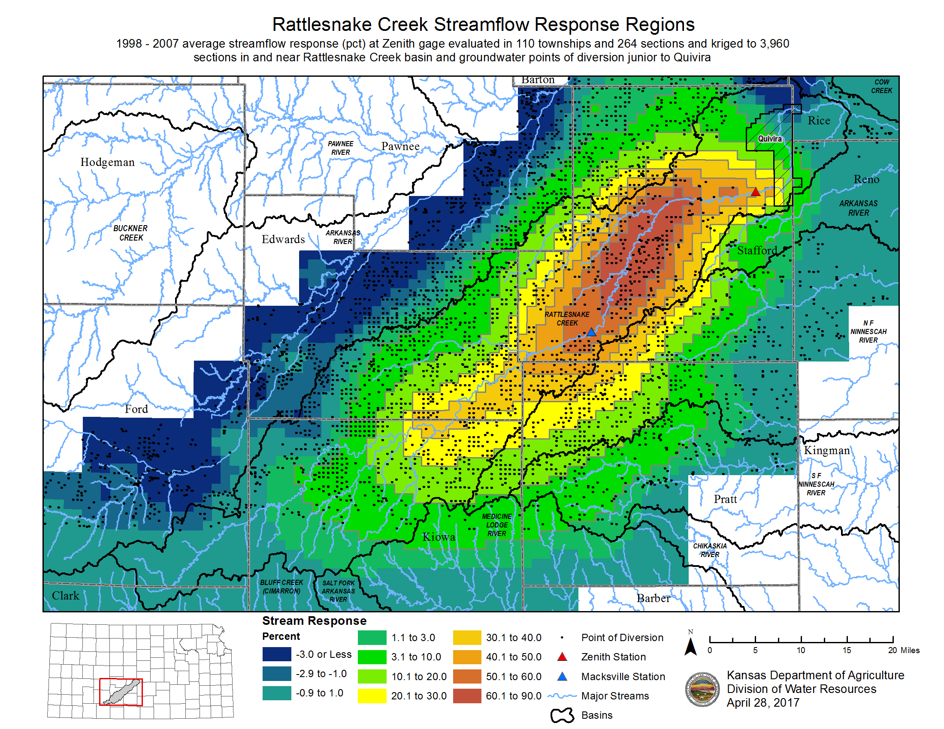
Fig. 2. Map of RSC depletion response at Zenith with points of diversion (by David Engelhaupt).
[image file GMD5_model_RSC_response_to_pumping_and_pd_locations.PNG]

