Memo: Update to GMD5 groundwater model scenarios produced by KDA-DWR

Narrative for additional GMD5 model backup files for revised depletion response map and future scenarios to reduce pumping within revised zone A

Sam Perkins

August 7, 2017

**Revised depletion response map**

The original depletion response map (Fig. 2 of memo dated June 19, 2017 and provided with original backup) was based on calculations for 263 PLSS sections, most of which applied a linear scaling to account for a preprocessing error in which the applied pumping was low by a factor of 12, as described on p. 4 of the original memo documenting our work with the GMD5 model. The discrepancy in response associated with this scaling was found to be small, on the order of one percent, for higher-response regions, but showed negative responses in areas distant from the Rattlesnake stream network.

To eliminate the assumption of linear depletion response to pumping that was used for the original response mapping, Scenario 16 was rerun for the original 263 PLSS sections and for an additional 220 sections, which were added to double the number of PLSS sections from two to four per township where depletion response was calculated. The depletion response calculated for 483 sections was kriged to 3960 PLSS sections. The response zones were revised (file RSC_Zenith_RspZones_rev.csv) and used to develop future scenarios for 15 and 30 percent reduction in pumping within the revised Zone A (10 pct or greater depletion response).

Fig. 1 shows the kriged depletion response map derived from the modeled depletion response at 483 PLSS sections. Fig. 2 plots changes between the original to revised depletion response (revised – original), and boundaries of zones A (10 percent or greater response) and B (20 percent or greater response) for the original and revised maps. Boundaries for zones A and B show negligible change except for zone A to the west of Rattlesnake C, where the revised boundary is shifted to the west by three miles.

**Model run backup for revised depletion response map**

The batch process used to run Scenario 16 for 483 PLSS sections, Map_rsp_scen16_GMD5.bat, is nearly the same as the corrected version that was used for the original response calculations, Map_rsp_scen16.bat; but it executes an additional postprocessor, cbcReader_RSGMD5, used to extract the local budget for all of GMD5 for each model run.

Backup for running Scenario 16 for the original 263 sections is in file build_GMD5_rspmap.zip, which contains the folder build_GMD5_rspmap. The batch file rerun_six_sets.bat lists the 263 subroutine calls that were made to Map_rsp_scen16_GMD5.bat. This list was divided into four groups of roughly 65 calls each. The zipfile was used to install the necessary files on three neighboring computers to divide the computation among four computers. Batch files for the model runs are in 1L\scenarios\bat, and were run from 1L\scenarios.

The model backup file file build_GMD5_rspmap.zip was updated to include batch files to run an additional 220 PLSS sections, listed on file run_set7.prn. The 220 model runs were divided into four batches of 55 runs each to run in parallel on four computers.

Depletion response summaries for the 463 PLSS sections were kriged to 3960 sections using the batch file run_krige_PLSS_rsp_483_sections.bat in in 1L\scenarios\krigersp. The model backup contains the text file readme_notes_re_running_model_to_update_response_map_spp_2017_0801.txt that provides additional procedural details that were followed in running the model and kriging the results.

**Future scenarios: 15 and 30 percent reduction in pumping within revised depletion response zone A**

The updated depletion response zones (file RSC_Zenith_RspZones_rev.csv) corresponding to the revised response map (Fig. 1) was used to specify future scenarios with 15 and 30 percent reductions in pumping beginning in 2018, based on the 2008-2068 future (BL_A sequence).

Fig. 3 plots projected RSC-Zenith streamflow depletion due to groundwater pumping in GMD5 for the base case and with 15 and 30 percent reductions in pumping within the revised Zone A beginning in 2018. [Projected depletion for the base case is based on the difference in projected streamflow between Scenario 13 and the base case, where Scenario 13 shuts off all pumping junior to File 5751 beginning in 1958.] Fig. 4 plots projected streamflow for the same cases. Fig. 5 plots projected additional streamflow provided by 15 and 30 percent pumping reductions within the revised zone A. Projected streamflow for 30 percent pumping reduction within the original zone A shows a slightly downward linear trend (Fig. 16 of original memo), whereas 30 percent reduction within the revised zone A, Fig. 4, shows a linear trend with nearly zero slope.

Table 1 and 2, which list 2018-2075 average global budget impacts and pumping reductions, have been expanded to include the above two scenarios. For the 15 and 30 percent pumping reductions within revised zone A, average streamflow increases by 4.5 cfs and 10.3 cfs, respectively.

**Model backup for added reduced pumping scenarios (15 and 30 pct within revised zone A)**

An incremental backup of required files for these scenarios is provided as file build_GMD5_ML_incr_update_2017_08.zip, along with an explanation of the files in readme_notes_re_ML_incr_update_2017_0804.txt. The original backup for the reduced pumping scenarios was also updated to include files for the two additional scenarios as file GMD5_ML_2017_08.zip.

**Tables**

Table 1. Pumping reduction impacts on global model water budget averaged over years 2018-2075.



Table 2. Changes in projected pumping under pumping reduction scenarios.



Figures

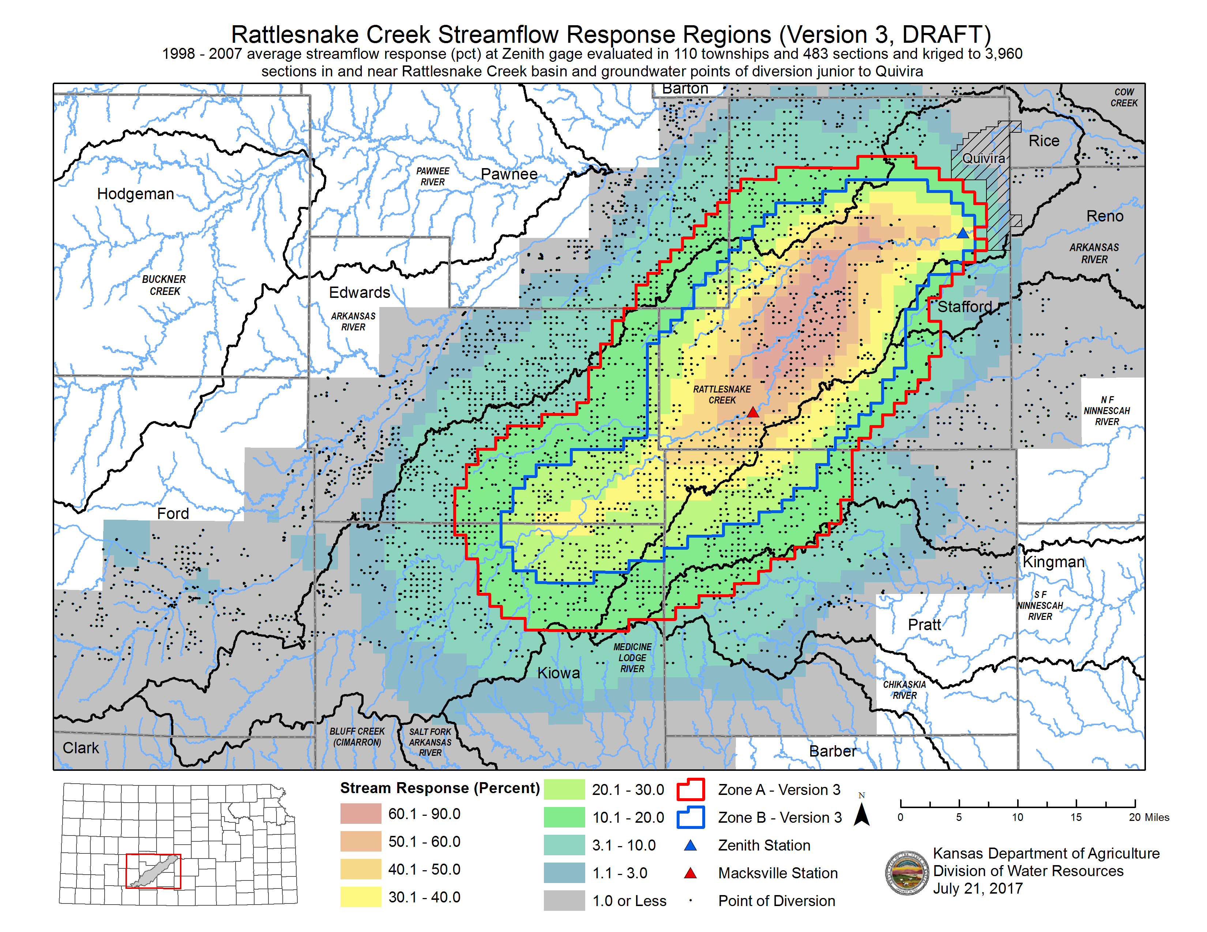

Fig. 1. Refined map of kriged RSC depletion response at Zenith with points of diversion (by David Engelhaupt), based on Scenario 16 model runs for 483 PLSS sections. Zone A: 10 pct (light green in map) or greater response; Zone B: 20 pct (yellow in map) or greater response. [image file Quivira_resp_v3.png]

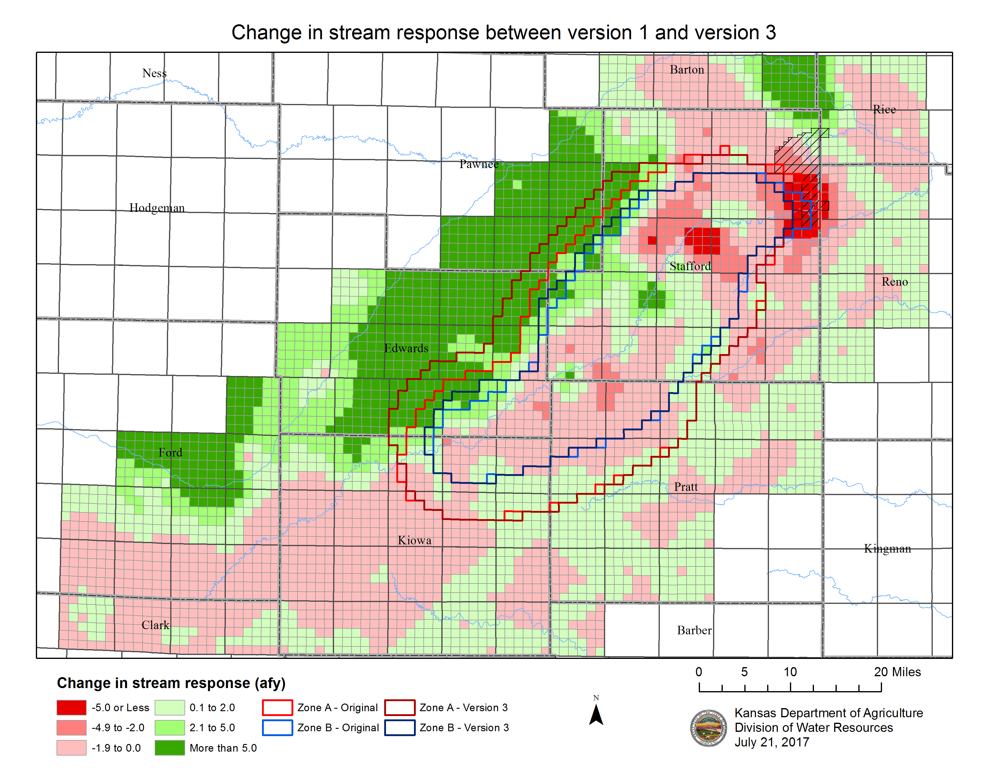

Fig. 2. Map of difference in stream depletion response for each PLSS section between the revised response (Fig. 3) and original (Fig. 2) response maps. Fig. 4 also shows original and revised boundaries of zones A and B. [Image file Quivira_resp_chng_v1_v3.png]

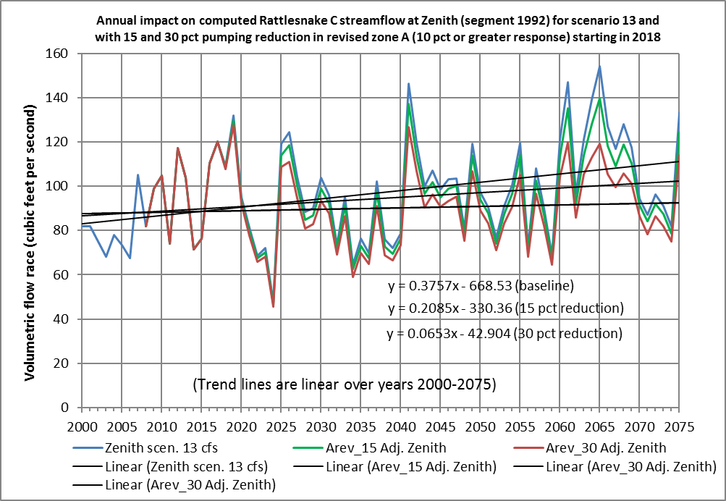

Fig. 3. Projected impact on RSC-Zenith streamflow for scenario 13 and with 15 and 30 percent pumping reductions within revised zone A (10 percent or greater response zone) beginning in 2018.

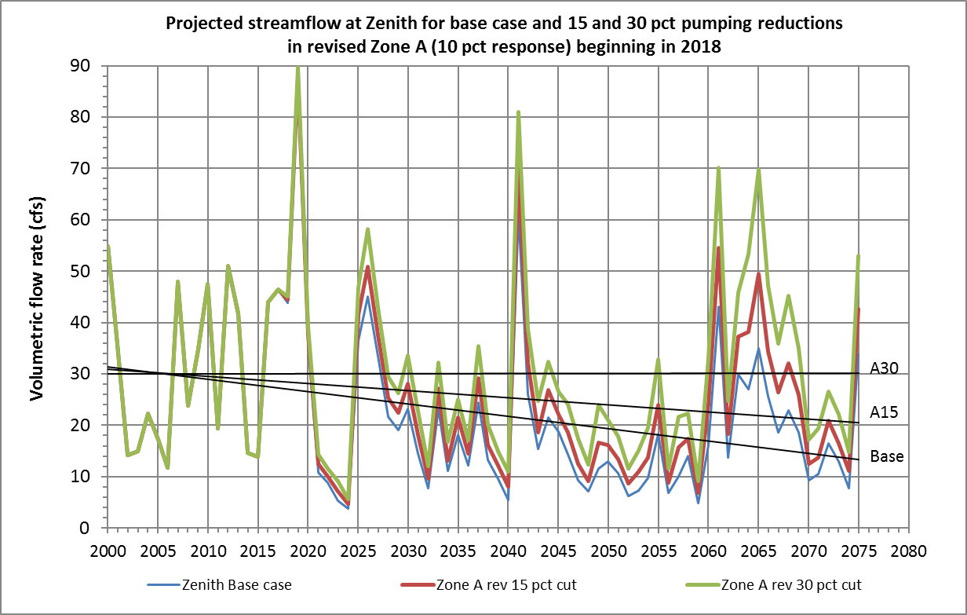Fig. 4. Projected RSC-Zenith streamflow for the base case and for 15 and 30 percent reductions in pumping within the revised Zone A (10 percent or greater response).

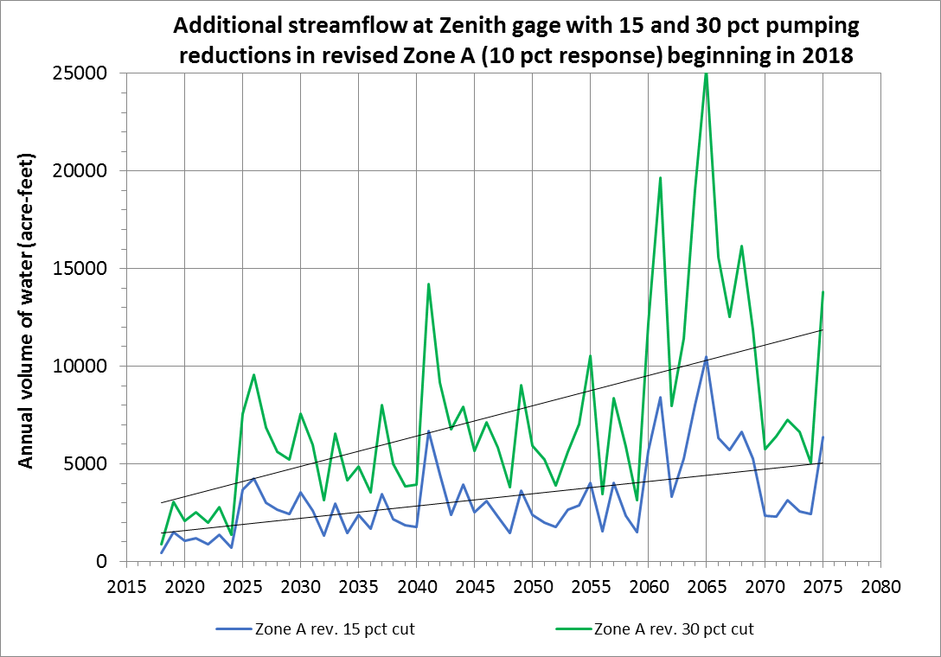

Fig. 5. Additional streamflow in RSC-Zenith with 15 and 30 pct pumping reductions beginning in 2018 within revised Zone A (10 pct response).