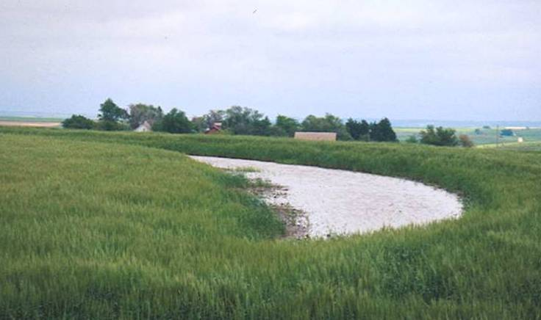
REPUBLICAN RIVER BASIN

Second Annual Status Report

STUDY ON THE IMPACTS OF
NON-FEDERAL RESERVOIRS AND
LAND TERRACING
ON BASIN WATER SUPPLIES

Prepared by

The Republican River Compact Settlement Conservation Committee
for
The Republican River Compact Administration

July 25, 2006

TABLE OF CONTENTS

Introduction 4

Study Plan Summary 4

Progress Since Approval of Study Plan 5

Funding Agreements 5

Evaluation and Modification of Existing Models 5

Development of Databases 6

On-the-Ground Verification 7

Expenditures 13

Study Timeline 15

Plans for Third Year 15

FIGURES

Figure 1. Example of Water Levels and Accumulated Precipitation for a Reservoir in Nebraska 8
Figure 2. Cross section view of typical terraced land 10

Figure 3. Pattern of volumetric water content for two months for the contributing
area at the Culbertson site. Site is planted to winter wheat. 12

Figure 4. Pattern of volumetric water content for two months for the terrace
channel at the Culbertson site where the terraces are conservation
bench terraces. 12

TABLES
Table 1. Summary of Study Expenditures. 13

APPENDICES

- States’ Inventory of Non-Federal Reservoirs

- List of 32 Sample Reservoir surface area monitoring sites

- Example of data collected for three of the 32 monitored reservoir sites
Dry Creek South 2-A, NE00559, Near McCook, NE;
Olson Dam, DRA0056, near Midway, Kansas; and
Flagler Reservoir near Flagler, CO.

- Condition Assessment of Terraces.

- Inventory of Terraced Lands.
- Detailed Progress Report of Kansas State University.

- Detailed Progress Report of University of Nebraska-Lincoln

INTRODUCTION

On May 26, 1998, Kansas filed suit in the U.S. Supreme Court complaining that the State of Nebraska had violated the Republican River Compact. On January 19, 1999, the Court accepted the lawsuit and assigned Vincent L. McKusick as Special Master. The three original parties to the Compact; Kansas, Nebraska and Colorado became parties to the case and the United States entered the case as amicus curiae. In December 2001, the Special Master granted a stay to allow the parties time to attempt to negotiate a settlement. On March 28, 2002, the negotiation teams for Kansas, Nebraska and Colorado signed a Statement of Settlement stating they had negotiated an Agreement in Principle to settle the Kansas v. Nebraska and Colorado litigation. On December 15, 2002, the states completed a Final Settlement Stipulation and the Special Master approved the stipulation in February 2003. The United States Supreme Court, by decree dated May 19, 2003, approved the Final Settlement Stipulation.

The Stipulation required the States, in cooperation with the United States, form a Conservation Committee by January 31, 2003. Further the stipulation required the Conservation Committee to develop a proposed study plan by April 30, 2004, to determine the quantitative effects of Non-Federal Reservoirs and land terracing practices on water supplies in the Republican River Basin above Hardy, Nebraska, including whether such effects can be determined for each of the Designated Drainage Basins (refer to Section VI of the Final Settlement Stipulation).

In January of 2003 each state and the United States appointed individuals to represent them on the Conservation Committee. The Conservation Committee members participated in a series of meeting and conference calls to develop a study plan to quantify the effects of Non-Federal Reservoirs and land terracing practices on water supplies in the Republican River Basin above Hardy, Nebraska. The study plan was transmitted to members of the Republican River Compact Administration (RRCA) on April 30, 2004. A Memorandum of Understanding was also provided with the study plan to identify the responsibilities of each party for funding and completing the study.

Representatives of the Conservation Committee attended the annual Republican River Compact meeting in Burlington, Colorado, on June 8 and 9, 2004, and presented the study plan to the RRCA. The RRCA verbally approved the study plan during the meeting and the signature process for the Memorandum of Understanding formally approving the study proposal was completed on July 27, 2004. July 27, 2004 is the official beginning date for the 5-year study.

STUDY PLAN SUMMARY

The study relies primarily on soil water balance models to simulate the impact of terraces and Non-Federal Reservoirs on surface water supply. The study consists of four primary components: 1. Evaluation and modification of existing models, 2. Development of databases, 3. On-the-ground verification, and 4. Application of the water balance and GIS models. A thorough description of the study plan is provided in the Republican River Basin Study Plan proposal on the Impacts of Non-Federal Reservoirs and Land Terracing on Basin Water Supplies dated April 28, 2004.

PROGRESS SINCE APPROVAL OF STUDY PLAN

A status report describing the progress made in completing the funding agreements for University of Nebraska-Lincoln (UNL) and Kansas State University (KSU) and the four primary phases of the study follows:

1. Funding Agreements: Reclamation entered into a 5-year agreement with the UNL in early October of 2004 to fund the majority of UNL’s role in the study effort. Funding to UNL became available in February of 2005. In March, 2005 Reclamation entered into a 5-year agreement with KSU to fund the majority of their role in the study. According to the agreements, Reclamation has agreed to provide $648,789 to UNL and KSU for the study effort.

2. Evaluation and Modification of the Existing Models: KSU is serving as the lead for the portion of the Research Project related to the development of the selected water balance model and for its application to land terraces and Non-Federal Reservoirs in the basin. Components of three computer simulation models, POTYLDR, SWAT, and CROPSM are being considered for integration into one model for simulation of the impacts of land terraces and Non-Federal Reservoirs. The SWAT model was developed by the USDA-ARS research team in Temple, Texas. The CROPSIM model was developed by Derrel Martin at UNL.

The POTYLDR model will serve as the basic framework for the water budget simulation model. POTYLDR simulates the water balance of representative tracts of land on a daily basis. The model allows for different land uses and estimates of water yield on a monthly or annual basis for a drainage area. Comparison of algorithms for various aspects of the water balance between POTYLDR and CROPSIM are underway. It is anticipated some of the algorithms from CROPSIM will be used in the unit-area version of the final model. The SWAT model has been evaluated. The SWAT model uses a feature representing the effect of land slope on RCN (Runoff Curve Number) and this feature will be incorporated into the water budget model.

The model will consist of four parts:
1. A GIS pre-processor will generate input data for the water budget simulation model hydrology response units (HRUs),
2. A unit area water budget simulation model will retrieve input data and will produce daily, monthly and annual water budgets for each HRU. Operation of a terraced field will be done as a HRU,
3. A water budget simulation model of a small reservoir using daily outputs from the HRUs, and
4. A GIS post-processor to combine results of the HRU and reservoir simulation models to produce monthly and annual recharge and runoff amounts.

Interactions and interfacing for data handling are in progress. A more precise method to simulate terraces is now under development. A separate simulation model for small reservoirs in a sub-basin will be developed to simulate the operation of the reservoir.

The research team expects to get the HRU model operational and under evaluation by the fall of 2006. The model will be applied to conditions in the selected test sub-basins, Prairie Dog Creek above Sebelius Lake and Medicine Creek above Harry Strunk Lake by the end of 2006.

A more detailed discussion of the water balance model and modeling approach is included in Appendix F.

- Development of Databases: Initial work was started to collect data and develop databases for Non-Federal Reservoirs and land terracing in the Republican River basin. Each state has completed an inventory of the Non-Federal Reservoirs in their portion of the basin. These inventories includes data related to reservoir location, size, date constructed, dam height and other reservoir characteristics. The inventories prepared by each state are included as Appendix A.

GIS mapping of terraced fields within the Republican River basin in Nebraska and within the Sappa Creek Basin in Kansas were previously prepared by the University of Nebraska. Digitized mapping provides a database of location and size of each of the terraced fields located within this portion of the basin. A comparable GIS mapping for the Republican River basin in Colorado and the remaining portion of the Republican River basin in Kansas above Hardy, Nebraska is in progress by Reclamation. Currently Prairie Dog Creek basin has been complete and work is continuing in Kansas west of the Sappa Creek basin. A map of the terraced lands in Nebraska and in the Sappa Creek Basin in Kansas is included as Figure 1 in Appendix E. A map of the terraced lands in the Prairie Dog Creek Basin in Kansas is included as Figure 2 in Appendix E.

Soils data from the SSURGO database have been downloaded for all counties in the Republican River basin. The database is currently being processed to reduce the large number of soil mapping units into a smaller set of classifications that will define the HRUs. Two types of weather data have been assembled. Data from the automated weather data network (AWDN) operated by the High Plains Regional Climate Center are being used to compute reference crop evapotranspiration. Data from the cooperative program operated by NOAA and the National Weather Services has also been assembled. Datasets from the National Hydrograph Dataset have been downloaded and will be used to delineate watershed boundaries and define contribution areas for specific reservoirs. Landuse datasets have been downloaded from the USGS. Tillage practices have been investigated for each county using the CTIC database. All this information will be used to define conditions in hydrologic response units.

Irrigation well locations are available for Nebraska and datasets for Colorado and Kansas are being explored. Stream flow records, including baseflow separation has been initiated but is not complete.

A more detailed discussion of the development of databases is included in Appendix G.

- On-the-Ground Verification: Initial study efforts were to establish sample monitoring sites in the field for both reservoirs and terraces as a part of the on-the-ground verification. The monitoring sites consist of a small sample of four reservoirs and five terrace sites for detailed data collection and monitoring and a larger sample of 32 reservoir sites for continual remote monitoring and recording of reservoir water levels and water surface area over the study period. Colorado, Kansas, and Nebraska were responsible for selecting representative sample reservoir sites for the continuous monitoring of reservoir water level. The sample of 32 reservoir sites was proportioned among the states based on the estimated total number of Non-Federal Reservoirs in the Republican River Basin compared with number of these reservoirs in each respective state. Based on these proportions, 1 reservoir sites were assigned to Colorado, 11 to Kansas, and 20 to Nebraska.

Reservoirs

(a.) Larger Sample of 32 Reservoirs Sites: Conservation Committee members and other Reclamation and State personnel met in McCook, Nebraska, on September 13, 2004, to begin installation of equipment and data collection at the reservoir sites. State and Reclamation staff continued installation of monitoring equipment as time allowed through the fall of 2004 and early spring of 2005. Monitoring equipment has been installed at a total of 32 sites. Initially plans were to install equipment at 35 sites, however, after reviewing the completed inventories for each of the states it was found that a much smaller number of reservoirs existed in Colorado than earlier estimated. Because of this, the 4 sites earlier planned for Colorado were reduced to one. Appendix C contains samples of this information for three reservoir sites; one in Kansas, one in Nebraska and one in Colorado. A list of the 32 reservoir sites being monitored is included in Appendix B.

The States will continue to make periodic site visits during the course of the study to retrieve water level data, determine reservoir surface area at corresponding water levels, and document overall conditions at the reservoir sites. Weather conditions have resulted in very little runoff to most of the reservoirs since data collection for the study began. Fifteen of the 32 reservoirs were dry during at least 2 of the 3 or 4 site visits since the beginning of the study. This has limited the amount of data collected, especially water surface area data necessary to construct water level-surface area-capacity curves needed to help define the water balance. Some important information is being collected, however, regarding how water levels fluctuate in these small reservoirs.
Figure 1 is an example of water level fluctuations for a reservoir in Nebraska. This reservoir is located west of Holdrege, Nebraska. The October 2004 through April 2006 precipitation totaled about 28.7 inches, 76 percent of average. Maximum storage occurring in this reservoir during the observation period was estimated at about 10 acre-feet during August 22, 2005. Similar information on three other reservoirs, one in each State, is included in Appendix C.

Figure 1. – Example of Water Levels and Accumulated Precipitation
for a Reservoir in Nebraska.

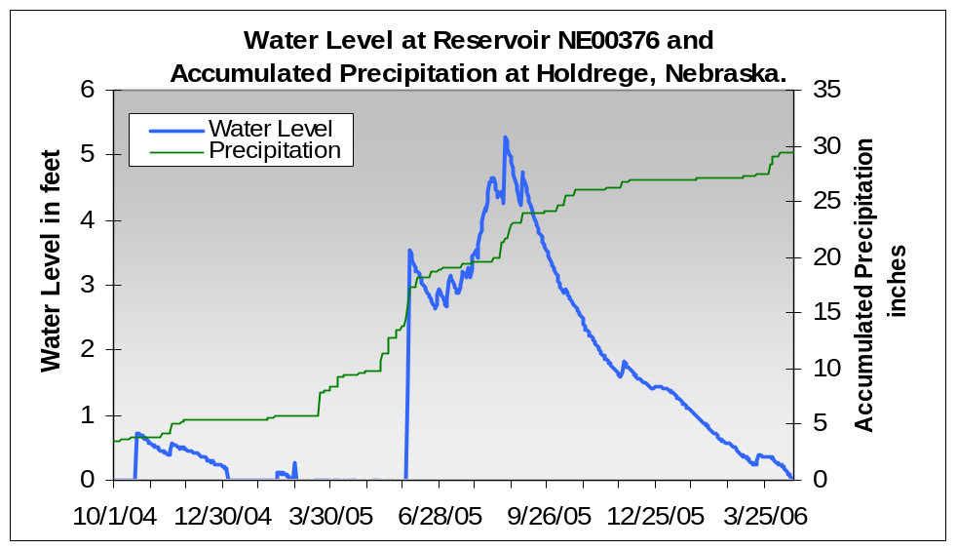

Kansas and Nebraska have set up ftp sites to archive the data and to make it available to the Conservation Committee. Kansas has also agreed to archive the data for the Colorado reservoir on their ftp site.

This aspect of the study is essentially on schedule and no anticipated problems are expected at this time.

(b.) Field Research at 4 Reservoir Sites:
Monitoring of reservoir evaporation rates is lagging behind schedule. The Bowen Ratio equipment that will be used to measure evaporation from a small pond was late in arriving. In addition, many of the reservoirs currently monitored have had very little water. The Bowen Ratio system needs to float on a lake and cannot set on a dry riverbed without damaging some sensors. Thus, additional reservoirs have been explored for locating the measuring equipment. The system should be ready to install by mid to late summer, 2006 (Appendix G).

Land Terracing

Three separate levels of investigation are needed for the land terracing inventory: (1) an overall inventory to determine the number, location and size of all terraced fields in the Republican River basin above Hardy, Nebraska; (2) a survey of a sample set of 20-25 terraced fields in each county in the basin (for a total of 400-500 terraced fields in the basin) to acquire information on terrace type, condition and other physical characteristics; and (3) a monitoring program for 5 sample terraced fields for detailed water balance studies.

(1) Overall Basin Terrace Inventory: GIS mapping of terraced fields in Colorado and the remaining portion of the Republican River basin in Kansas above Hardy, Nebraska is in progress by Reclamation. Currently Prairie Dog Creek basin has been complete. Preliminary review of the mapping indicates there are 273,124 acres terraced in Prairie Dog Creek Basin in Kansas. Work will continue in Kansas west of the Sappa Creek basin. Nebraska previous completed the mapping of terraced lands in Nebraska and in the Sappa Creek Basin in Kansas. Maps of the terraced lands are included as Figure 1 and Figure 2 in Appendix E.

(2). Survey of Sample Set of Terraced Fields: It is believed that a sample set of 20-25 terraced fields in each county is needed to provide an adequate sample of the variation in characteristics between the terraced fields. An investigation form identifying data that should be collected during the field investigations of the terraced fields is included in Appendix D.

The Conservation Committee made a recommendation to the RRCA at the July 27, 2005, annual meeting that a request for the Natural Resources Conservation Service (NRCS) assistance would be beneficial in assessing the condition of terraces. The RRCA agreed and sent a letter of request for assistance to the NRCS. In response to that request for assistance, the NRCS and the Conservation Committee developed a plan for a pilot study to assess terrace condition.

The pilot study will examine terraces in the Medicine Creek basin in Frontier County, Nebraska and in Prairie Dog Creek basin in Decatur County, Kansas. The Conservation Committee identified 15-20 potential terraced fields in each county, listed in Appendix D, and the NRCS would do an office assessment of 10 of these terraced fields per county, and field check 2-3 of the sites per county. The goal of this assessment is to identify the as-built condition of the terrace and determine the present condition. The results of the pilot study will be used to determine how to proceed with assessing terrace conditions in the remainder of the basin.

(3) Field Research at 5 Terraced Sites: Five sites were selected for the field research on the impact of terraces. The sites include two conservation bench terrace systems located near Culbertson, Nebraska and Colby, Kansas; two level terrace systems with closed ends located near Curtis, Nebraska and Norton, Kansas; and one level terrace system with open end(s) located near Stamford, Nebraska (Figure 1 of Appendix G).

Data collection equipment has been installed at the five field research terraced sites. Equipment has been installed to measure and record precipitation and reference evapo-transpiration at each site. Water level information is also collected in the terrace channel. Volumetric water content of the soil is being collected at various depths in both the contributing area above the terrace channel and in the terraced channel. Soil moisture data is also being collected using matric potential sensors in both the contributing area and in the terrace channel. Soil temperatures are also being collected. Figure 2 indicates the relative location of the contributing area and the terrace channel.

Figure 2. – Cross Sectional View of Typical Terraced Land.

TERRACECHANNEL
BERM
CONTRIBUTING AREA
TERRACE INTERVAL
CHANNEL WIDTH

Field site instrumentation has all been completed with the exception of the runoff station at the open-ended terrace system near Stamford, NE. Field work planned in the near future includes ring infiltrometer tests for determination of parameters for the Green-Ampt infiltration equation.

The final aspect of the field investigations for the impact of terraces involves deep drilling of soil cores to a depth of 25 feet. Soil samples from the terrace channels and in the contributing areas were obtained to this depth. The soil cores were analyzed and results of the comparisons at the Culbertson Site show that considerably more water is stored in the soil profile beneath the terrace channels than in the soil profile beneath the contributing area.

Some preliminary data are illustrated in Figures 3 and 4 (also in Appendix G, Figures 20 and 21) for the Culbertson Site where winter wheat is raised on a field that has conservation bench terraces. The water content shows that the terrace channel experiences more water input following the precipitation on March 26 and 27, 2006. The water content of the soils in the terrace channel increased about 7% while the water content of soils in the contributing area only increased by about 2 to 3%. The water content patterns show the water use from the profile as the crop began to grow and transpire in the spring.

A more detailed discussion of the on-the-ground-verification, including data collection to help define the water balance at both the reservoir and land terraced sites, is included in Appendix G.

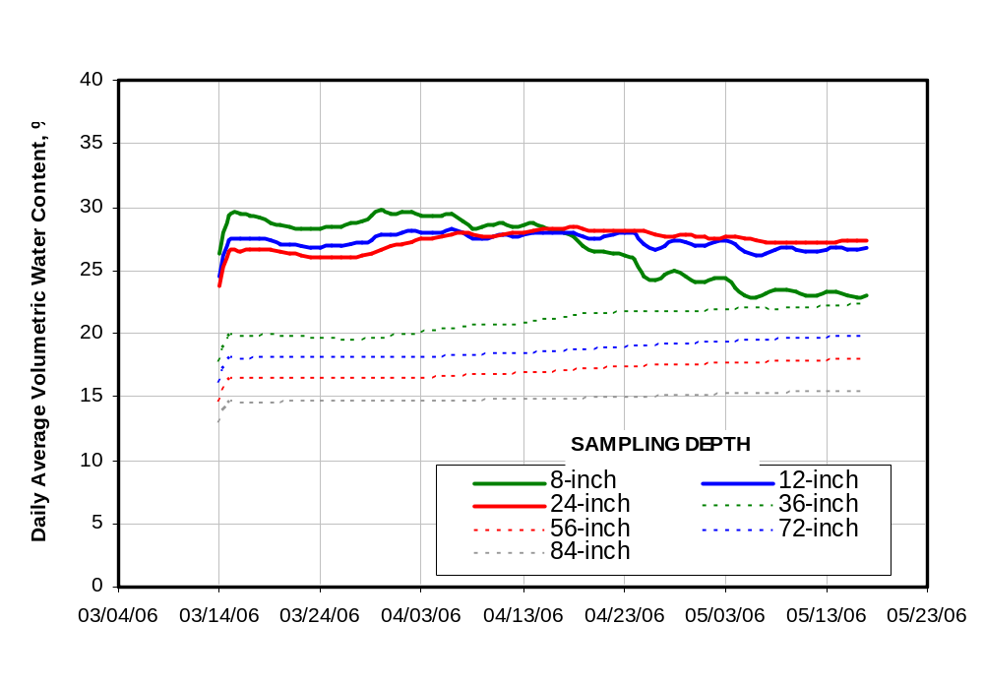Figure 3. --Pattern of volumetric water content for two months for the contributing area
at the Culbertson site. Site is planted to winter wheat.

Figure 4. Pattern of volumetric water content for two months for the terrace channel at the Culbertson Site where the terraces are conservation bench terraces.
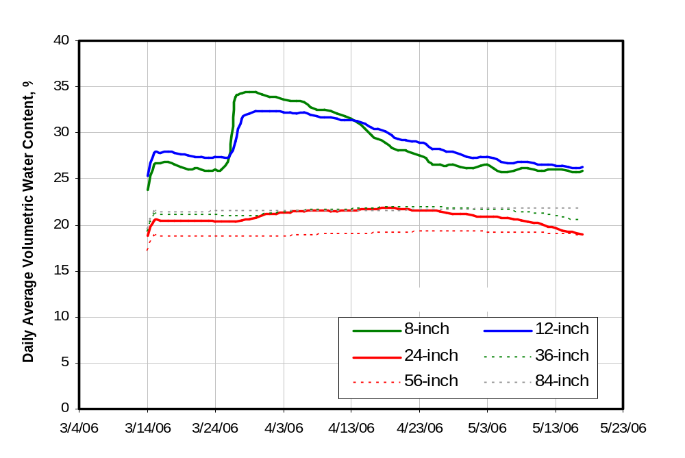

EXPENDITURES

The Final Settlement Stipulation specifies that the States and the United States will undertake this study at a cost not to exceed one million dollars of which the United States will be responsible for 75 percent of the cost and each State will be responsible for one third of the remaining 25% ($83,333 per State). The States’ portion may be provided entirely through in-kind contributions. If the cost of the study exceeds one million dollars, the United States will be responsible for the entire additional amount.

The Study Plan Proposal of April 28, 2004, specified that the in-kind contributions of the States reported in the status reports would cover the period from April 1 of the previous fiscal year through March 31 of the current fiscal year. However, this status report includes costs for May 1 through April 30 as these costs provide a more up-to-date status. Table 1 shows the expenditures by each entity for each of the study years.

Table 1. -- Summary of Study Expenditures

 | Study Proposal Development | Study Expenditure Year¹
 | Study Proposal Development | 2005  Study Yr 1 | 2006  Study Yr 2 | 2007  Study Yr 3 | 2008  Study Yr 4 | 2009  Study Yr 5 | Total
Colorado | $23,820 | $5,625 | $3,744 |  |  |  | $ 9,369
Kansas³ | 40,009 | 22,307 | 4,904 |  |  |  | 27,211
Nebraska | 12,938 | 23,219 | 28,023 |  |  |  | 51,242
KSU |  | 0 | 45,400 | 11,410² |  |  | 56,810
UNL |  | 0 | 189,400 | 17,600² |  |  | 207,000
Reclamation⁴ |  | 64,876 | 25,350 | 37,869² |  |  | 128,095
NRCS |  | --- | ---
Total |  | $116,027 | $296,821 | $66,879² |  |  | $479,727
¹ The Study was approved on July 27, 2004. The Study Expenditure Year for this table is defined as the period from July 27, 2004 through April 30, 2005 for Study Year 1, and May 1 through April 30 for the other study years, unless otherwise noted.
² Expenditures for May 1, 2006 thru June 13, 2006.
³ Expenditures are July 1 through June 30 for 2005, and July 1 through April 30, 2006.
⁴ Expenditures separate from funds provided to KSU and UNL under agreements.

Colorado – Colorado has provided in-kind contributions toward the study by selecting one reservoir site, assisting with the installation of equipment for monitoring the operation of the reservoir, and by assisting with other work related to the study. Colorado has contributed $9,369 of in-kind services towards the study from the date of approval of the study on July 27, 2004 through April 30, 2006.

Kansas - Kansas Division of Water Resources, Department of Agriculture, has provided staff time, plus expenses in the form of per diem cost for travel, training, installation of instruments and monitoring and maintenance on the instruments on a sample of 11 reservoirs and by assisting with other work related to the study. Kansas has contributed $27,211 of in-kind services towards the study from the date of approval of the study on July 27, 2004 through April 30, 2006.

Nebraska – Nebraska has provided in-kind contributions toward the study by selecting sites, assisting with the installation of equipment for monitoring the operation of 20 reservoirs, and by assisting with other work related to the study. Nebraska conducts site visits to the 20 reservoir sites at least twice per year to download water level recorder data and to collect water surface perimeter data using GPS. Nebraska has contributed $51,242 of in-kind services towards the study from the date of approval of the study on July 27, 2004 through April 30, 2006.

Kansas State University – Through June 13, 2006, KSU’s Cooperative Agreement expenditures have been about $56,810. Reclamation has obligated a total of $131,700 to KSU leaving $74,890 of unexpended funds. Additional funding of $137,426 is budgeted to cover work preformed during 2007 through 2008

University of Nebraska - Through June 13, 2006, UNL’s Cooperative Agreement expenditures have totaled about $207,000. Reclamation has obligated a total of $284,800 to UNL leaving $77,000 of unexpended funds. Additional funding of $94,864 is budgeted to cover work preformed during 2007 through 2008

Reclamation – Reclamation committed staff time and funding for purchase and installation of equipment related to the larger sample of 32 reservoirs. In addition Reclamation committed staff time for preparation and administration of the funding. Total expenditures by Reclamation for the above work from the time the MOU was signed through April 30, 2005 were about $94,226. An additional $37,869 was expended from April 30 through June 13, 2006.

According to the agreements with UNL and KSU, Reclamation has agreed to provide $648,789 for the universities’ study effort. To date, Reclamation has obligated $284,800 to UNL and $131,700 to KSU under their respective funding agreements to meet the universities’ expected expenditures through September, 2006. Of this amount, UNL and KSU have expended $207,000 and $56,810, respectively. Obligated funds that are unused in fiscal year 2006 will be available for work in future years.

Reclamation Great Plains Region submitted a proposal through the Reclamation Science and Technology Program seeking additional funding for the study. The study proposal was selected and funded for $30,000 in fiscal year 2006. This funding is being used by Reclamation staff for mapping of terraced fields (terraced field inventory) in Kansas and Colorado. Additional funds will be requested for fiscal years 2007 through 2009.

NRCS – The NRCS committed staff time and travel expenses for the pilot study to identify as-built condition of the terraces and determine present condition. The expenditures for this work was not available at the time of printing of this report.

STUDY TIMELINE

For the first year, progress on the study was on schedule for installation and monitoring of the larger sample of 32 reservoirs but behind schedule on most other aspects of the study by 4-5 months. It was anticipated that only 2-3 months of potential data collection would be lost from the delay in installation of monitoring equipment for the detailed field research. Good progress was made in assembling geographic information needed for the study.

During the second year the study has fallen further behind schedule, primarily caused by delays on installation of equipment to collect data at the field research sites to collect detail information regarding the water balance for the small reservoir and land terrace sites. The Conservation Committee generally believes that good results can be obtained by the planned completion date of the study. Two and one-half to three years of detailed data collection at the reservoir and terrace sites should still provide good information regarding the water balance at the sites.

PLANS FOR THIRD YEAR

Data collection for the reservoir and land terrace sites will continue through this year and until near the end of 2008. The mapping of terraced lands in Kansas and Colorado is expected to be completed in 2007. The assessment of terrace condition will be a major activity in the next year. A more detailed plan for assessment of terrace condition is expected to begin development in August 2006 following review of the pilot study results. Kansas plans to survey the 11 monitored reservoirs during the fall of 2006 to gather information to develop water level-area-capacity curves. Nebraska plans to survey the three remaining reservoirs monitored as part of this study that currently do not have area-capacity curves to gather information to develop water level-area-capacity curves.

The remaining objectives for the project are underway but depend on the form and development of the simulation models. The research team expects to modify the simulation model and then to develop the GIS interface. This will be a high priority project for the summer and early fall of 2006. The research team expects to get the HRU model operational and under evaluation by the fall of 2006. The model will be applied to conditions in the selected test sub-basins, Prairie Dog Creek above Sebelius Lake and Medicine Creek above Harry Strunk Lake by the end of 2006.

